CIS40A Lab 7-1: Packet Tracer – Networking Cisco Academy.

In this lab, we will be using Packet Tracer, which is a simulator for Cisco appliances. Using Packet Tracer will help you become familiarized with network diagrams, configuration in CLI and GUI. You will need to sign up for free access to Introduction to Packet Tracer course, which provides you details on Packet Tracer. You will be able to download Packet Tracer through the free course access.
*If you already have a Cisco Academy account, you can login to the account. You can begin this lab using at Part B.
Provide necessary screen captures and answers in various steps.

Part A: Sign-up for Cisco Academy and Download Packet Tracer
- Visit NetACad website and click Learn More under Intro to Packet tracer course information.
- Click Sign Up Today! and English button to sign up for the free course. Cisco requires course registration to access Packet Tracer.
- Fill in the Enrollment form using your school e-mail address, then click Create Account.
- Login your school e-mail and click Activate Account button on the e-mail.

Part B: Download Packet Tracer 8
- Login NetACad website and click Resources
- Click Download Packet Tracer. You should copy the downloaded executable to your USB flash drive so you will have it to use outside of school.
- Open Downloads folder and click the executable file to begin the installation of Packet Tracer.
- Once the installation is completed, open Packet Tracer and begin the next activity.

Part C: Using Packet Tracer to set up a small network.
Topology:
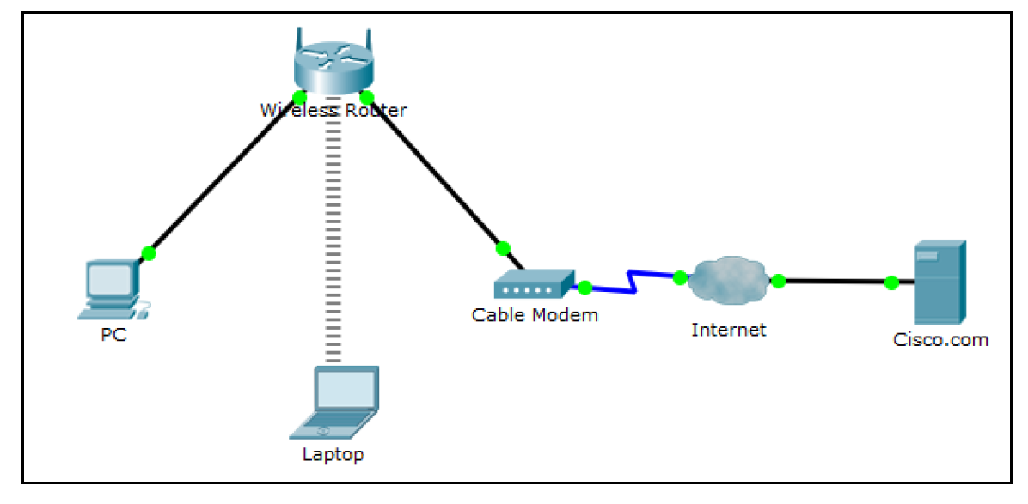

Address Table
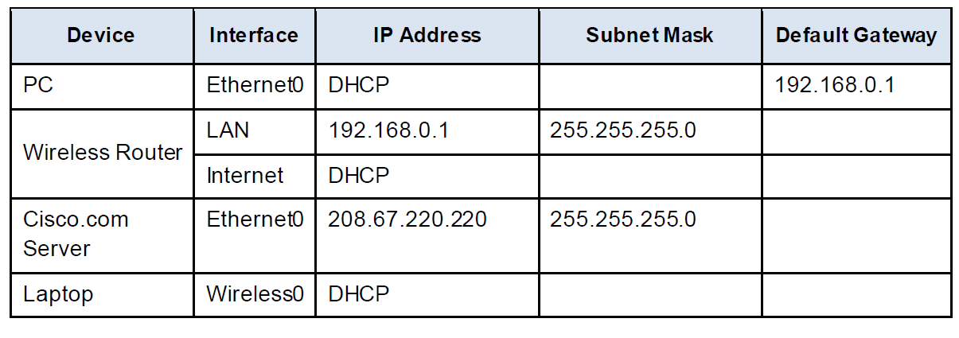
In this activity you will build a simple network in Packet Tracer from scratch and then save the network as a Packet Tracer Activity File (.pkt).
- Open Packet Tracer app.
- Add network devices to the workspace.
- Using the device selection box, add the network devices to the workspace as shown in the topology diagram.
- To place a device onto the workspace, first choose a device type from the Device-Type Selection box. Then, click on the desired device model from the Device-Specific Selection box.
- Finally, click on a location in the workspace to put your device in that location. If you want to cancel your selection, click the Cancel icon for that device. Alternatively, you can click and drag a device from the Device-Specific Selection box onto the workspace.
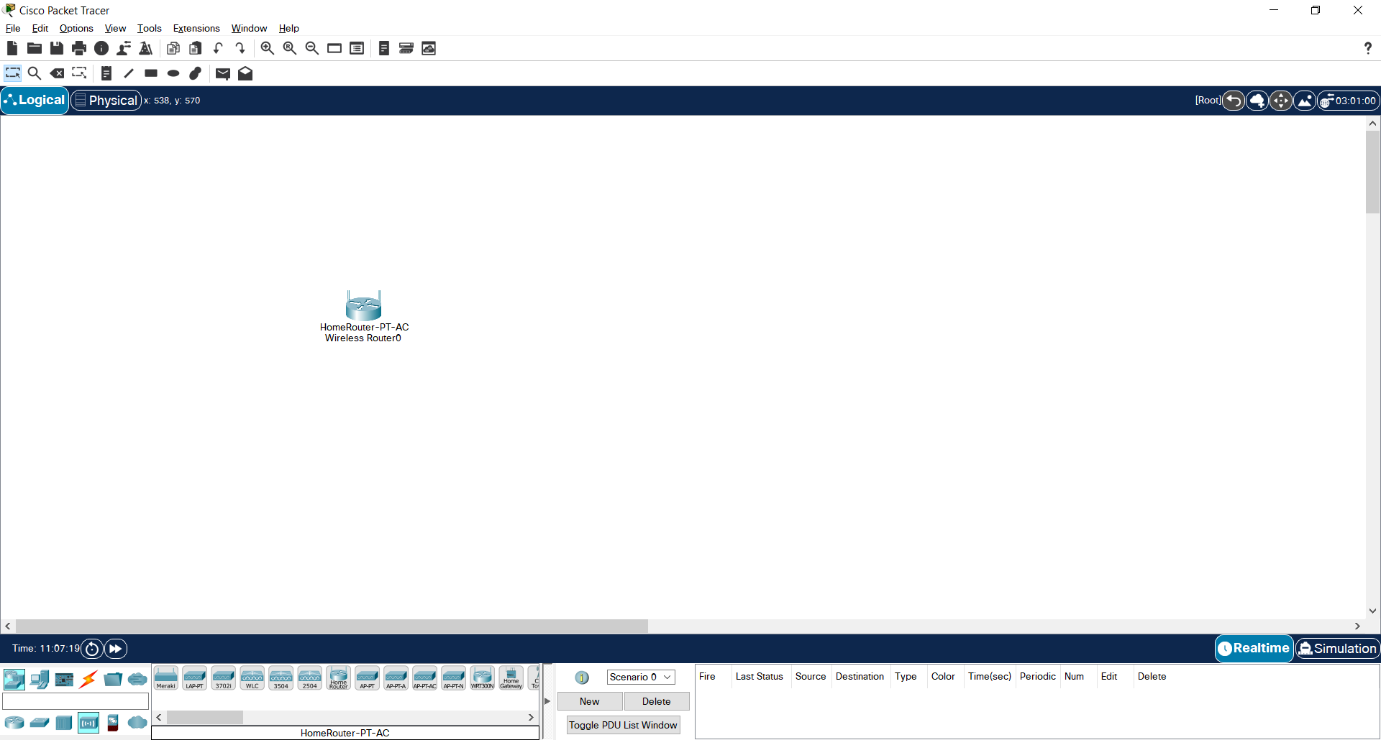

- Add network devices to the workspace.
- Using the device selection box, add the network devices to the workspace as shown in the topology diagram
- To place a device onto the workspace, first choose a device type from the Device-Type Selection box. Then, click on the desired device model from the Device-Specific Selection box.
- Finally, click on a location in the workspace to put your device in that location. If you want to cancel your selection, click the Cancel icon for that device. Alternatively, you can click and drag a device from the Device-Specific Selection box onto the workspace.
- Change display names of the network devices.
To change the display names of the network devices, click on the device icon on the Packet Tracer Logical workspace, then click on the Config tab in the device configuration window. In the Config tab type, the new name of the device into the Display Name box as show in the figure.

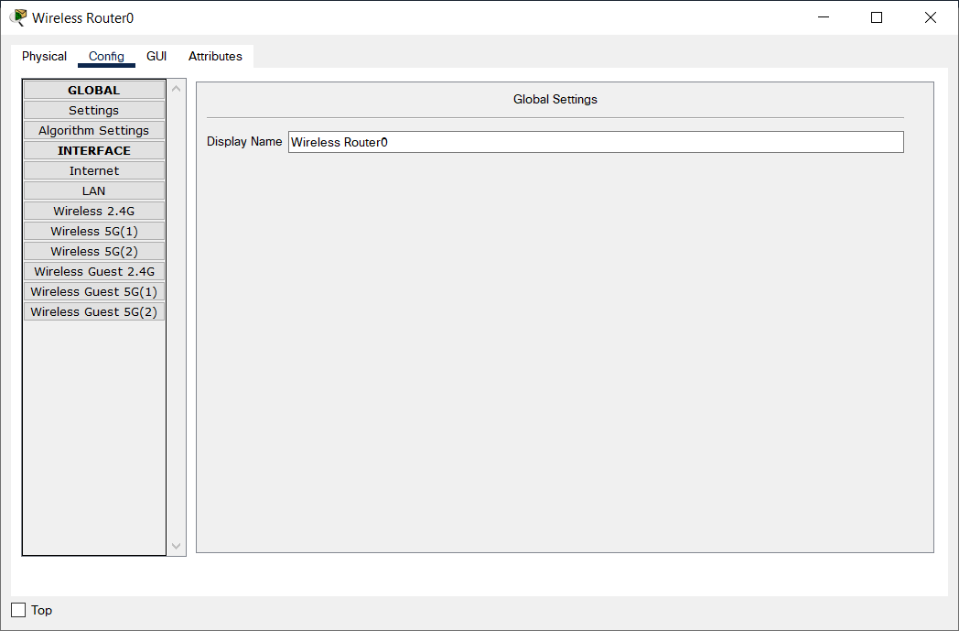

- Add the physical cabling between devices on the workspace
- Using the device selection box, add the physical cabling between devices on the workspace as shown in the topology diagram.
- The PC will need a copper straight-through cable to connect to the Wireless Router. Select the copper straight-through cable in the Device-Selection box and attach it to the FastEthernet0 interface of the PC and the Ethernet 1 interface of the Wireless Router.
- The Wireless Router will need a copper straight-through cable to connect to the Cable Modem. Select the copper straight-through cable in the Device-Selection box and attach it to the Internet interface of the Wireless Router and the Port 1 interface of the Cable Modem.
- The Cable Modem will need a coaxial cable to connect to the Internet cloud. Select the coaxial cable in the Device-Selection box and attach it to the Port 0 interface of the Cable Modem and the coaxial interface of the Internet cloud.
- The Internet cloud will need copper straight-through cable to connect to the Cisco.com server. Select the copper straight-through cable in the Device-Selection box and attach it to the Ethernet interface of the Internet cloud and the FastEthernet0 interface of the Cisco.com server.

Configure Wireless Router in Packet Tracer
- Create the wireless network on the Wireless Router
- Click on the Wireless Router icon on the Packet Tracer Logical workspace to open the device configuration window.
- In the Wireless Router configuration window click on the GUI tab to view configuration options for the Wireless Router.
- Next, click on the Wireless tab in the GUI to view the wireless settings. The only setting that needs to be changed from the defaults is the Network Name (SSID). Here, type the name “HomeNetwork” as shown in the figure.
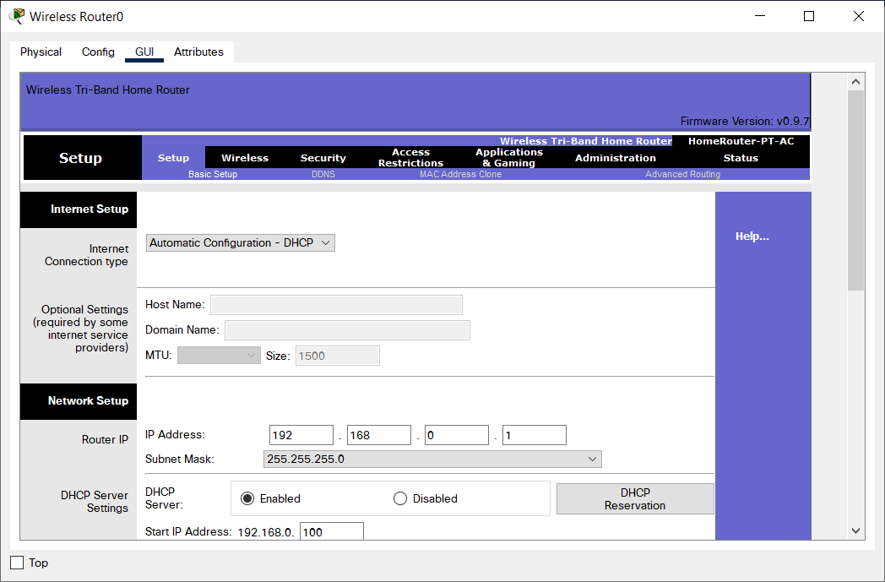
- Configure the Internet connection on the Wireless Router
- Click on the Setup tab in the Wireless Router GUI.
- In the DHCP Server settings verify that the Enabled button is selected and configure the static IP address of the DNS server as 208.67.220.220 as shown in the figure.
- Click on the Save Settings tab.

Configure Laptop in Packet Tracer
- Configure the Laptop to access the wireless network
- Click on the Laptop icon on the Packet Tracer Logical workspace and in the Laptop configuration windows select the Physical tab.
- In the Physical tab you will need to remove the Ethernet copper module and replace it with the Wireless WPC300N module.
- To do this, you first power the Laptop off by clicking the power button on the side of the laptop.
- Then remove the currently installed Ethernet copper module by clicking on the module on the side of the laptop and dragging it to the MODULES pane on the left of the Laptop window.
- Then install the Wireless WPC300N module by clicking on it in the MODULES pane and dragging it to the empty module port on the side of the laptop. Power the laptop back on by clicking on the Laptop power button again.
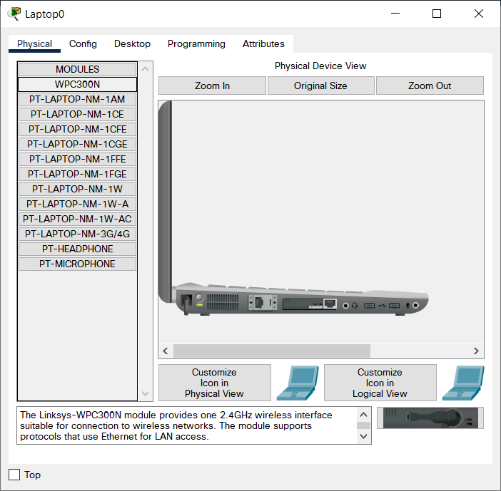

- With the wireless module installed, the next task is to connect the laptop to the wireless network.
- Click on the Desktop tab at the top of the Laptop configuration window and select the PC Wireless icon.
- Once the Wireless-N Notebook Adapter settings are visible, select the Connect tab. The wireless network “HomeNetwork” should be visible in the list of wireless networks as shown in the figure.
- Select the network and click on the Connect tab found below the Site Information.
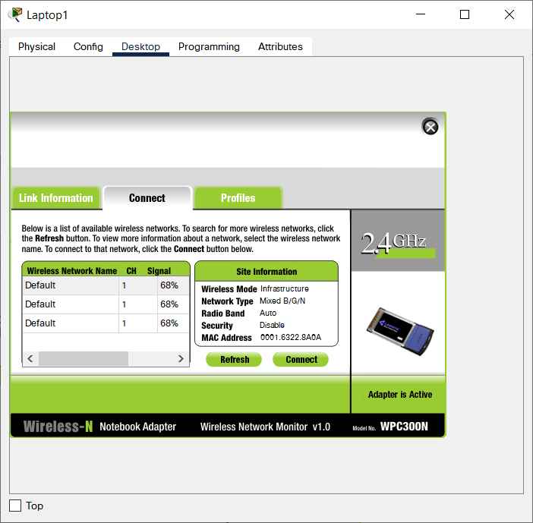

Configure the PC

- Configure the PC for the wired network
- Click on the PC icon on the Packet Tracer Logical workspace and select the Desktop tab and then the IP Configuration icon.
- In the IP Configuration window, select the DCHP radio button as shown in the figure so that the PC will use DCHP to receive an IPv4 address from the Wireless router.
- Close the IP Configuration window.
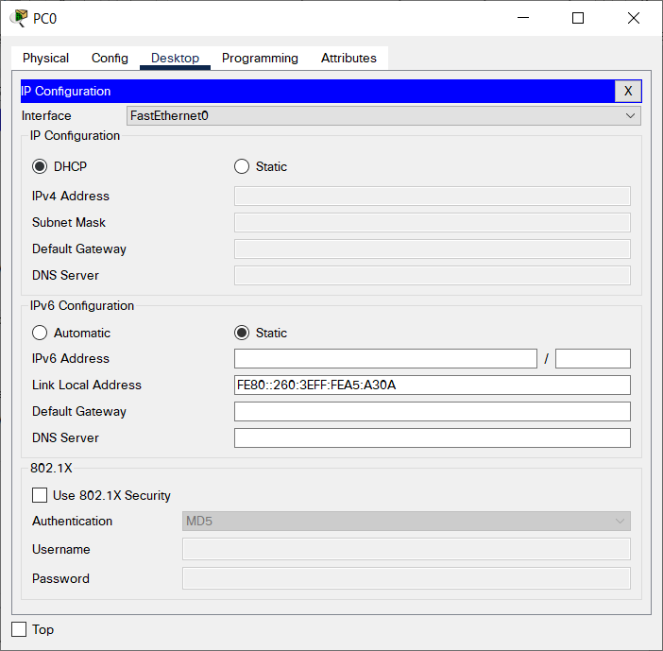

- Click on the Command Prompt icon. Verify the PC has received an IPv4 address by issuing the ipconfig /all command from the Command as shown in the figure. The PC should receive an IPv4 address in the 192.168.0.x range.

Configure Internet Cloud in Packet Tracer
- Install network modules if necessary.
- Click on the Internet Cloud icon on the Packet Tracer Logical workspace and then click on the Physical tab.
- The cloud device will need two modules if they are not already installed. The PT-CLOUD-NM-1CX which is for the cable modem service connection and the PT-CLOUD-NM-1CFE which is for a copper Ethernet cable connection. If these modules are missing, power off the physical cloud devices by clicking on the power button and drag each module to an empty module port on the device and then power the device back on.
- Identify the From and To Ports:
- Click on the Config tab in the Cloud device window. In the left pane click on Cable under CONNECTIONS.
- In the first drop-down box choose Coaxial and in the second drop down box choose Ethernet then click the Add button to add these as the From Port and To Port as shown in the figure.

- Identify the type of provider:
- While still in the Config tab click Ethernet under INTERFACE in the left pane. In the Ethernet configuration window select Cable as the Provider Network as shown in the figure.

Configure Cisco Server
- Configure the Cisco.com server as a DHCP server
- Click on the Cisco.com server icon on the Packet Tracer Logical workspace and select the Services tab.
- Select DHCP from the SERVICES list in the left pane.
- In the DHCP configuration window, configure a DHCP as shown in the figure with the following settings. Click On to turn the DCHP service on
- Pool name: DHCPpool
- Default Gateway: 208.67.220.220
- DNS Server: 208.67.220.220
- Starting IP Address: 208.67.220.1
- Subnet Mask 255.255.255.0
- Maximum number of Users: 50
Provide screen capture of configuration
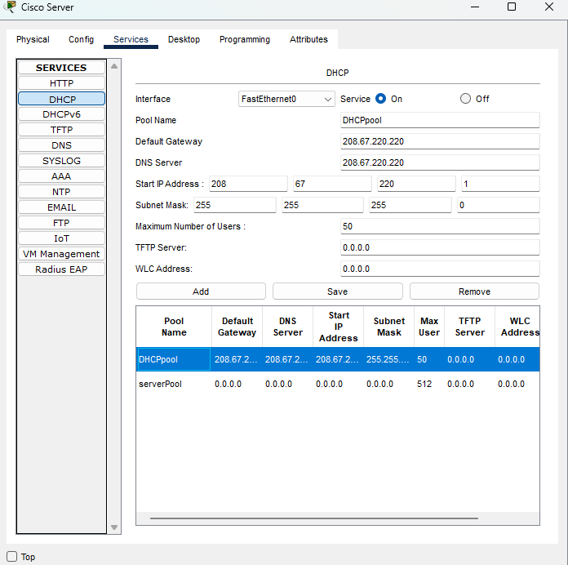
- Configure the Cisco.com server as a DNS server to provide domain name to IPv4 address resolution.
- Still in the Services tab, select DNS from the SERVICES listed in the left pane.
- Configure the DNS service using the following settings as shown in the figure.
- Click On to turn the DNS service on.
- Name: Cisco.com
- Type: A Record
- Address: 208.67.220.220
- Click Add to add the DNS service settings.
Provide screen capture of configuration.
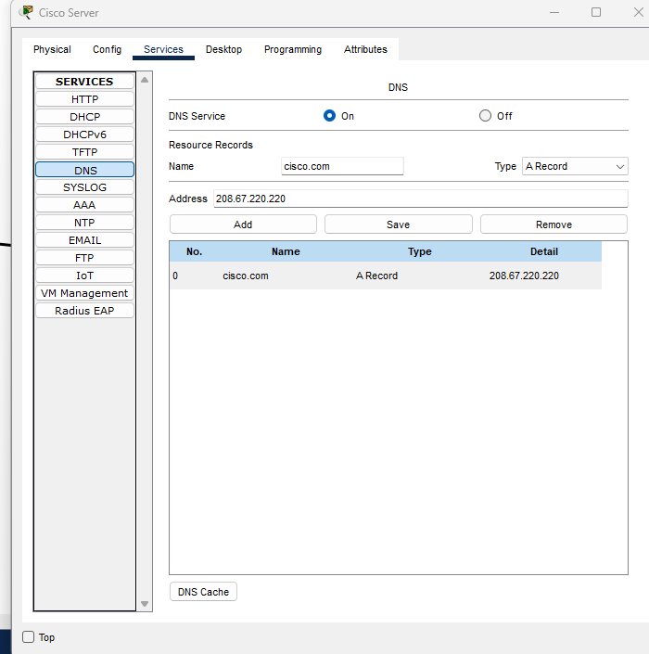

- Configure the Cisco.com server Global settings.
- Select the Config tab.
- Click on Settings in left pane.
- Configure the Global settings of the server as follows:
  - Select Static
  - Gateway: 208.67.220.1
  - DNS Server: 208.67.220.220
Provide screen capture of configuration.
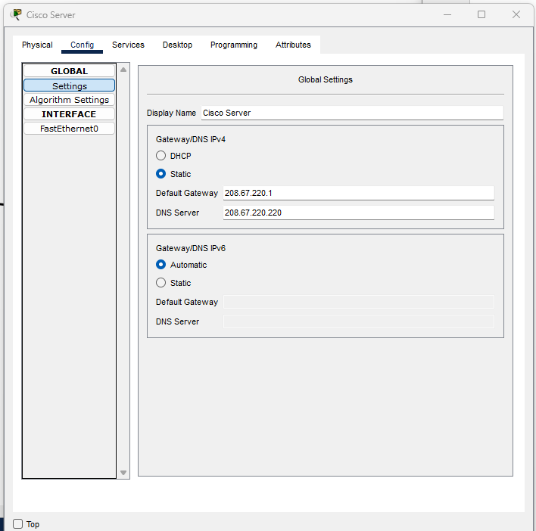
- Configure the Cisco.com server FastEthernet0 Interface settings.
- Click on FastEthernet in left pane of the Config tab
- Configure the FastEthernet Interface settings of the server as follows:
- Select Static under IP Configuration
- IP Address: 208.67.220.220
- Subnet Mask: 255.255.255.0
Provide screen capture of configuration. 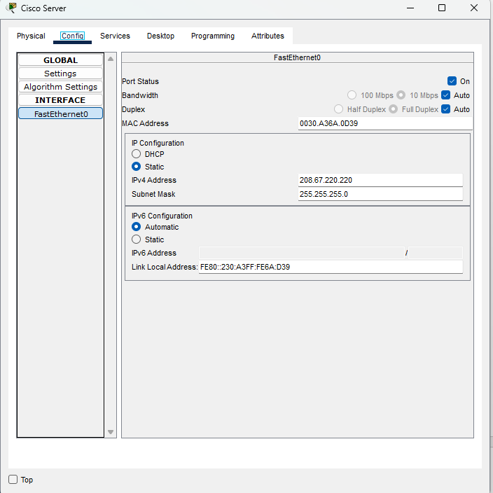

Verify Connectivity
Refresh the IPv4 settings on the PC
- Verify that the PC is receiving IPv4 configuration information from DHCP.
- Click on the PC on the Packet Tracer Logical workspace and then the select the Desktop tab of the PC configuration window.
- Click on the Command Prompt icon
- In the command prompt refresh the IP settings by issuing the commands ipconfig /release and then ipconfig /renew. The output should show that the PC has an IP address in the 192.168.0.x range, a subnet mask, a Default Gateway, and DNS server address as shown in the figure.
Provide screen capture of command prompt output.
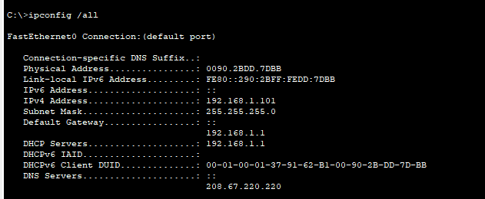

Save File in Packet Tracer
Save the File as a Packet Tracer Activity File (*.pkt)
- To save the completed network click on File in the Packet Tracer Menu bar and then select Save As… from the dropdown menu. In the Save File window choose a directory to save the file to and give the file an appropriate file name. The Save as type defaults to Packet Tracer Activity File (*.pkt). Click Save to save the file.
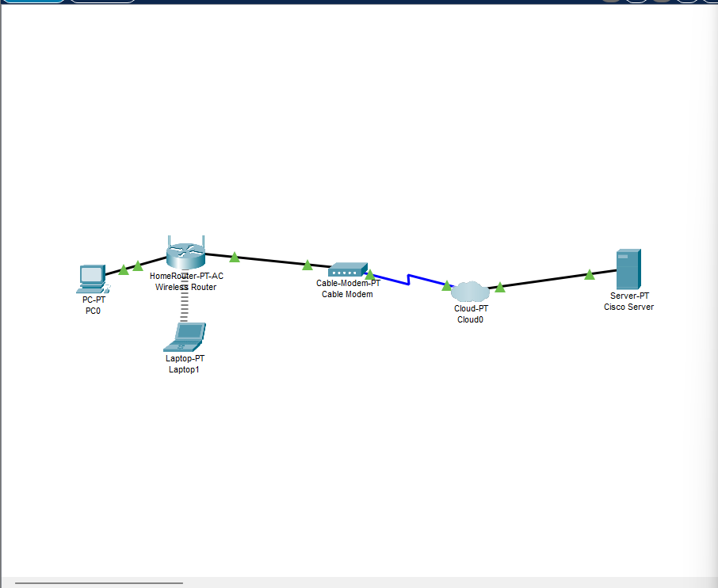

Part D: Deploying Cabling Services in Packet Tracer
- Download the “Deploying and Cabling Devices.pkt” file from Canvas. *You can also find this file in Chapter 2 of Packet Tracer course on Netacad.
- Open the “Deploying and Cabling Devices.pkt” file.
- The first task in this activity is to practice using the Device-Type Selection Box. The top row of icons represents categories of devices, and the bottom row represents subcategories. Point at the top row of icons slowly and look at the Label box between the rows, the names of the categories will appear. Now point at the lower row icons and you will see their names appear. In this activity we will deploy Switches and PCs. Point at the lower row icons until you see one labeled Switches. Click on that icon and you will see the devices in the Device-Specific Selection Box change.
It now shows the switches available in Packet Tracer.

Deploy two 2960 switches (if you don’t remember how review the previous activity) over the Switch0 and Switch1 labels in the workspace.

- Now click on the End Device category in the Device-Type Selection Box, and deploy six PCs. If you are unsure of which device is the PC just point at the device in the Device-Specific Selection Box and look at the label area below the devices, it should say PC-PT (remember that you don’t have to select the PC icon six times to deploy them, there is a shortcut). Your workspace should now look like this.

- We are now going to connect the PCs to the switches.
Click on the category that looks like a lightning bolt labeled Connections. In the Device-Specific Selection Box, there will appear a series of cable types, select the Copper Straight-Through cable type. Now point at the center of PC0 and click on it. You will see a pop-up menu appear showing the cable connection types. Point and click on the FastEthernet0 selection. Now a wire will appear anchored to the PC. Point at Switch0 and click on it. Another pop-up menu will appear with a much larger set of selections, point at, and click on the FastEthernet0/1 selection. The cable will now be connected and two blinking link lights will appear: one green and one amber. After a while the amber light will turn green for reasons you will understand as you learn about networking.
- We are going to cable all six PCs to the switches.
- Either select the cable each time or use the <CTRL> key just like in first activity. This is the set of connections to be done.
- PC1 FastEthernet0 to Switch0 FastEthernet0/2
- PC2 FastEthernet0 to Switch0 FastEthernet0/3
- PC3 FastEthernet0 to Switch1 FastEthernet0/1
- PC4 FastEthernet0 to Switch1 FastEthernet0/2
- PC5 FastEthernet0 to Switch1 FastEthernet0/3
If you used the <CTRL> key to do multiple copies cancel it by clicking on the cancel indicator.
- Now we need a different type of cable to connect the two switches. Select a Copper Cross-Over cable.
- Click on it and then point at and click on Switch0. From the pop-up menu select the Gigabit0/1 interface near the bottom of the list. Then point at and click Switch1 and select the same interface from this list. The cable will appear and both link lights will be amber but will eventually turn to green after about a minute.

- Save file and take a screen capture of your workspace.
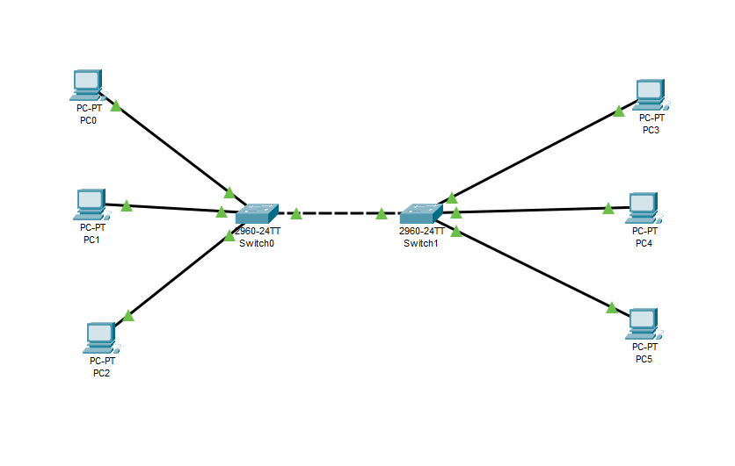
- Close Packet Tracer and log off NetaCad website.
- Login Canvas and submit Lab 7-1.

